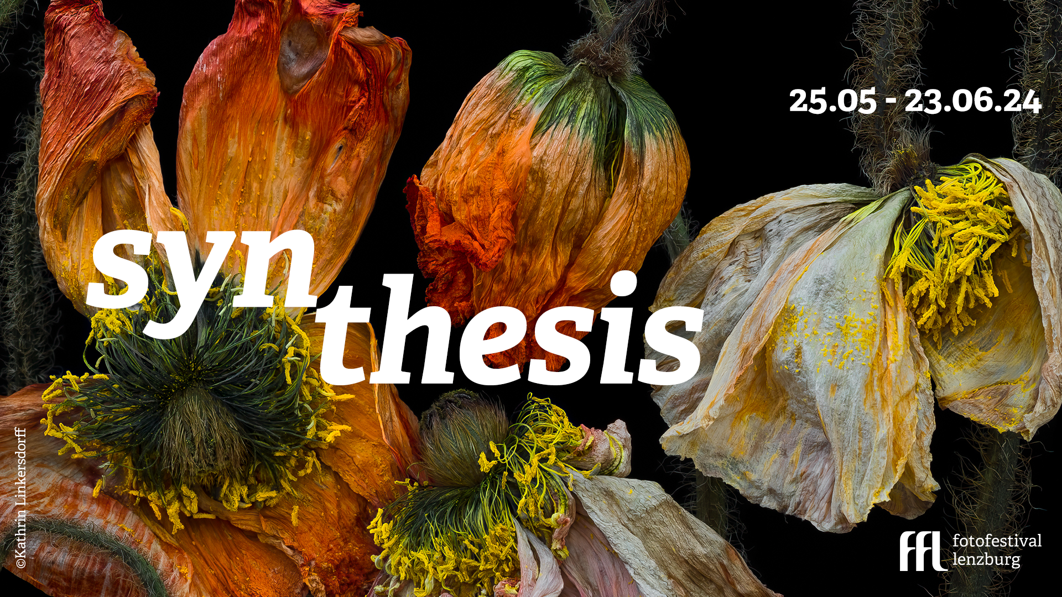

Press release date: 03 May 2024

Fotofestival Lenzburg
25.05. – 23.06. 2024
Lenzburg und Aarau

Fotofestival Lenzburg presents the sixth edition with the theme ‘Synthesis’

Fotofestival Lenzburg announces the sixth edition of its event, which will take place in Lenzburg from 25 May to 23 June 2024.

With 20 exhibitions in 16 locations, authors from 3 continents and numerous events with international guests, the 2024 edition is the richest and most comprehensive in the history of the festival.

A synthesis of numerous topics

With this year's theme of ‘Synthesis’, the exhibitions encourage us to reflect on the rapid development of technological possibilities and the continuous stream of impressions that each individual experiences. In the face of this diversity, people can lose themselves, but also find ways to rediscover, search and question themselves as they strive to find balance within and without. This year's theme is also reflected in the art on display, as a reflection on the permanence and metamorphosis of the image.
From the reflection on light pollution to the fascination of images in which bacteria are the artists, from the love affair with food to the art of play and the diversity of human relationships - the photographic projects of the exhibited artists deal with numerous topics that are of absolute urgency in our society and at the same time arouse emotions and stimulate reflection.

The social commitment

With a wide range of exhibitions, workshops, talks and events, the Lenzburg Fotofestival aims to continue to bring people together and promote cultural exchange. ‘The sixth edition of Fotofestival Lenzburg epitomises our efforts to enrich the cultural landscape, promote talent and create a platform for critical discussion,’ says festival director Margherita Guerra. ‘We are proud to showcase photographers and artists from Switzerland and around the world, while engaging local communities and emphasising our commitment to sustainability and social awareness.’

The highlights of the sixth edition of the Lenzburg Fotofestival

- With over 300 images in 20 indoor exhibitions and open-air installations at 16 locations, the festival offers an experience that represents the diversity and depth of contemporary photography.
- An opening weekend during which the authors will be travelling from three continents to personally guide visitors through their exhibitions and be available for interviews.
- The ‘Bold And Talented Programme’, which promotes talented photographers and aspiring Swiss curators and brings international exhibitions to Lenzburg.
- The launch of the first catalogue, which documents the artistic maturity of the festival and makes a lasting contribution to the art world.
- The only Swiss photo festival to present a selection of this year's winning images from the Sony World Photography Awards.
- Action Bound: picture hunt for schools and families to bring children closer to art in a playful way.
- Other events such as author talks, workshops and guided tours that promote education and cultural exchange.
- Several reading corners with selected photo books in catering establishments.
- A cult booth from which Lenzburg residents and visitors to the festival can send greetings from Lenzburg to the world using our postcard.
- 54 pictures adorn the shops in Lenzburg and compete for the popular public prize worth CHF 1000, sponsored by SWL AG Lenzburg.
- Exhibitions at the town's best-known locations: Stapferhaus, Schloss Lenzburg, Burghalde Museum, Villa Müllerhaus, Aarau City Museum as well as at new locations such as Villa Sonneberg, the Kraftreaktor and the panorama rooms in the Ex-Hero Areal, Dammweg 19. The festival offers the opportunity to rediscover Lenzburg through the lens of photography.

Agenda

Saturday, 25 May 2024, from 10:00 am, Lenzburg
Opening of the Fotofestival (mit festival pass)
10:00 Opening of the exhibitions in Lenzburg and Aarau
10:00 – 17:00 Guided tours with authors and curators, full list here
18:00 Vernissage & Apéro with official presentation of the 6th edition at the Stapferhaus, Lenzburg. With pre-booking here.
21:00 Kraft party with DJ set by Pablo Color at Kraftreaktor

Sunday, 26 May 2024, 11:00 am Prosecco talk, at the Burghaldenhaus Lenzburg Grand Theft Photo: Photography in digital spaces - a dialogue with Marco de Mutiis, digital curator for photography, Fotomuseum Winterthur. In co-operation with KulturKommission Lenzburg. Without festival pass with admission fee.

Friday, 07 June 2024 Special Guest Supper
in cooperation with the Reformed Church Suhr-Hunzenschwil

Saturday, 22 June 2024 - Talk ‘The art of microorganisms’
with Sibylle Lichtensteiger, Artistic Director Stapferhaus, Kathrin Linkersdorff, author of the exhibition ‘Microverses’ and Prof. Regina Hengge, Professor of Biology at the University of Humboldt, Berlin.

You can find all updates in our online agenda.

List of exhibitions and authors

1 Mattia Balsamini, Italien – Protege Noctem- Dammweg 19
2 Markus Bühler, Schweiz – In the year if the forest – Museum Burghalde
3 Luisa Dörr, Brasilien – Imilla - Kraftreaktor
4 Federico Estol, Uruguay– Shine Heroes – Mühlimatt-Unterführung
5 Anja Furrer, Schweiz – Sonnenberg – Villa Sonnenberg
6 Maria Giovanna Giuliano, Italien – Ordinary Pleasures – Schloss Lenzburg
7 Jana Hartmann, Deutschland – Mastering the Elements - Promenade
8 Sabine Hess, Schweiz – You Felt The Roots Grow - Schloss Lenzburg
9 Kathrin Linkersdorff, Deutschland – MICROVERSES - Stapferhaus
10 Aurelie Pétrel , Frankreich– Midnight at Rolands - Villa Sonnenberg
11 Katie Prock, Vereinigte Staaten von Amerika – Yesterday We Were Girls - Dammweg 19
12 Paulo Simão, Portugal – Erased – Markus Roth-Platz und Stadtmuseum Aarau
13 Jansen van Staden, Südafrika – Microlight – Dammweg Wasseranlage
14 Anastasia Samoylova, Vereinigte Staaten von Amerika - Image Cities - Schloss Lenzburg
15 Marta Zgierska, Polen – Tomorrow crumbles in hands – Dammweg 19

16 Gruppenausstellung - The Photographer‘s Guides to Los Santos – Dammweg 19
With artworks by Raphael Brunk, Alan Butler, Mattia Dagani Rio, Elizabeth Desintaputri, Claire Hentschker, COLL.EO, Georgie Roxby Smith, 2girls1comp.

17 Group exhibition - The Last Supper - Müllerhaus
With artworks by Damaris Betancourt, Cortis & Sonderegger, Johanna Maria Fritz, Gabriele Galimberti & Paolo Woods, Moira Ricci, Jan Von Holleben.

18 Group exhibiton - Sony World Photography Awards 2024 – In the garden of Schloss Lenzburg, Museum Burghalde, Müllerhaus

19 Digital exhibition Synthesis in time - 29 red dots throughout the town take visitors back in time. Lenzburg then and now can be experienced digitally using QR codes.

20 Group exhibition Synthesis- Winning pictures of Open Call - Lenzburg shops

Here you can find more information about the exhibitions.

Festival pass

The festival pass costs CHF 20 (CHF 15 with discounts for students / Kulturlegi holders) and is valid for the entire duration of the festival.

- All guided tours on the opening weekend included

- Power party on the opening weekend included

- Free access to the castle garden

- Free admission to the permanent exhibition in the Aarau City Museum

- Reduced admission to the NATUR exhibition in the Stapferhaus

Partners and sponsors

The extensive network of cultural partners that has been built up over the years makes the Lenzburg Fotofestival an internationally recognised cultural event in the photography scene that is attracting an increasing number of visitors.

Swisslos Aargau, Lebensraum Aargau, SWL Energie AG Lenzburg, BAT Foundation Lausanne, Stadt Lenzburg, DigiCulture Fachstelle Kulturvermittlung, Departement Bildung, Kultur und Sport, Kanton Aargau, Ortsbürgerkulturkommission Lenzburg, Stapferhaus Lenzburg, Schloss Lenzburg, Kromer Werbetechnik Lenzburg, Nikin Lenzburg, Obrist Lenzburg, Regimo Aarau, Müllerhaus Lenzburg, Museum Burghalde Lenzburg, Kraftreaktor Lenzburg, World Photography Organisation London, Villa Sonneberg Lenzburg, Gowen Contemporary Genf, Artphilein Foundation Lugano, Fotofestival Yeast Matino (IT), Biennale della Fotografia Femminile Mantova (IT), SONY Schweiz.

The Fotofestival Lenzburg cordially invites media representatives, photography enthusiasts and the general public to take part in this cultural event and experience the synthesis of art, technology and society.

Further information on exhibitions, events and tickets can be found on the festival's official website at www.fotofestivallenzburg.ch/en/

We have compiled a dossier with images, banners and texts for your publication.

From 24 to 26 May, all authors will be present and available for interviews.

The director Margherita Guerra and the curators will be available for further questions and interviews.

Contact for press enquiries: Anetta Damm Fotofestival Lenzburg
E-Mail: anetta@fotofestivallenzburg.ch
Telephone number: +41 78 203 4581

